Assignment 1 Step 7-11

By Kristen Rose

Step 7 – Inventories
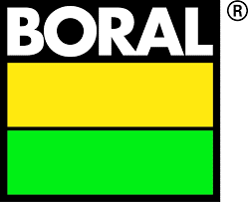
For this step, we have been asked to look out our inventory for our company. My company is Boral LTD. The first thing I did was check to see if my company had an inventory, which it did. I looked back through the financial statements for the last four years to see if there were any major differences in how the inventory was presented. There were no differences at all that I could see. The reports were laid out the same.
In terms of how locating the inventory on the financial statements, it was not difficult to find or figure it out. The balance sheet lists inventories as ‘inventory’ and has inventory values are listed under both current and non-current assets in the last four financial statements.
The income statement refers to the selling of inventory as ‘cost of sales’ in all financial statements and there are no other entries relating to inventory/costs in the income statement.
After looking at this I referred myself to the notes to read if there was any more information on inventories. There were no notes listed against costs of sales, but there were notes for the inventory.
I was disappointed to see that the amount of information written about the inventory was quite small. The opening statement was this “inventories are valued at the lower of cost of net realisable value. Net realisable value represents the estimated selling price less all estimated costs of completion and costs to be incurred in marketing, selling and distribution.”
Now to break down what this actually means… The net realisable value is an estimate of the cost of the item. This may be the actual cost of everything or a calculated average of cost. Once this estimate is determined, the costs incurred due to marketing, selling and distribution and completion are subtracted. This then gives the overall value of the inventory.
Boral lists a breakdown of their inventory in terms of current assets and non-current assets. Current assets include:
- Raw materials and consumables,
- Work in progress,
- Finished goods, and
- Land development projects.
Non-current assets include:
- Land development projects.
The land development projects comprise of:
- Cost of acquisition, and
- Development costs capitalised.
I reviewed the inventory notes for the last four annual reports and they were all the same (with differing numbers of course). I could not find any information in regards to whether Boral uses the perpetual method or the periodic method for their inventory system. I made an assumption that they used the perpetual method due to the fact that they only have one line on the income statement in relation to costs. I recall in the lecture about inventories that if firms use the periodic method, they will have a number of line items showing the calculation of cost of sales. I did not see this in Boral’s financial statements.
Looking at the statements to try and figure out which method of inventories they use had me quite stumped. It wasn’t written anywhere, so I was left to try and figure it out, or make a base assumption from what I already know about Boral. I honestly don’t know if my assumption is correct or not.
I read through the accounting standards AASB102 in regards to inventories, which stated financial statements should disclose the policy adopted in measuring inventories as well as the cost formula used. Based on this, I started to think it must be somewhere in the annual report. So maybe I just needed to dig a little deeper?
I sifted through the reports, used the search functions, tried many different key words, but I could not come up with anything that concretely stated which inventory method the company uses and how they cost their inventory. My assumption for how they cost their inventory is that they are using either specific identification, FIFO or the averaging method (so, basically I have no idea...) I am leaning towards specific identification for certain items as the company focuses on construction and building and likely has a variety of different assets in the inventory that would meet the requirements for this method. In contrast, they may have some resources, for example their fly ash, which I don’t think meets requirements to be calculated under the specific identification method and is more likely suitable under the averaging method or FIFO. The LIFO method is of course, illegal in Australia, so at least I can be certain that they don’t use that method.
I am left to think they perhaps use a combination of specific identification, FIFO and averaging. I’m not really sure if that is common, perhaps it is… Overall, I have no idea and am left feeling frustrated as to why I cannot figure it out. Am I missing something? Or are the annual reports so vague that I am not meant to know how they calculate their inventory?
Or, I wonder. Perhaps it is vague on purpose. Boral would have such a vast inventory, spanning from raw materials to land development projects, managing the inventory would be a tricky job. Maybe they don’t really want us to know how they work it out…
So, how has Boral’s inventories differed from the last four financial statements? The following figures are straight from the firm’s Balance Sheets. 2016 showed a collective inventory of current and not current assets at $565.9 million. 2017 $619.7 million, 2018 $625.2 million and 2019 $695.2 million. So, over the years, Boral has been steadily increasing their total inventory. This could mean that over the years, their sales are going down, or they have made some purchases/investments into infrastructure that is increasing their overall inventory asset. To see if there has been a decline in their sales of inventory, I take a look at their cost of sales figures over the last four financial statements.
2016 ($2672.5) million, 2017 ($2858.4) million, 2018 ($3701.3) million and 2019 ($3845.6) million. This is also an increasing trend. So while Boral’s inventories are increasing, so are their sales. The assumption here is that the increase in their inventory is to accommodate for their growing increasing in sales, as opposed to a decline in sales. This is promising for the company.
Above, I provided a list of what the inventories entail, which is largely a combination of raw materials, finished goods, works in progress and development projects. One thing to note of interest is that in the most recent financial statement, Boral showed a significant reduction in net profit along with a large increase in financial obligations. Their net profit went from $441 million in 2018 to $272.4 million in 2019. However, as written above, their inventories went up. In terms of current liabilities, their loans and borrowings went from $19.2 million to $339.7 million. That’s a huge difference between the two years. In terms of their inventory, based on these figures, I have made the assumption that the increase in inventory is likely a large increase in raw materials and development projects, as opposed to finished products. It would be interesting to take a look at their financial report in 2020 to see what the numbers are doing now.

Step 8 – MYOB Training
I really don’t know if I have the correct screen shots, but here’s hoping…
Below screen shot is of the last step for the set up tutorial.
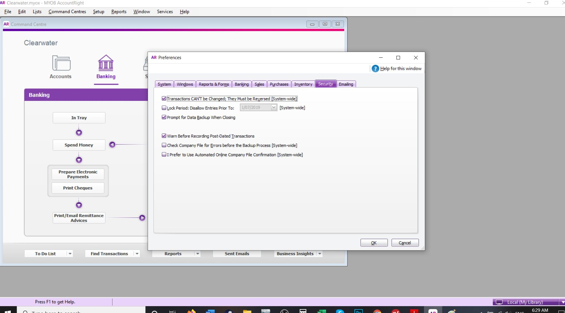

Screen shot after completing the second tutorial – Using Account Right.
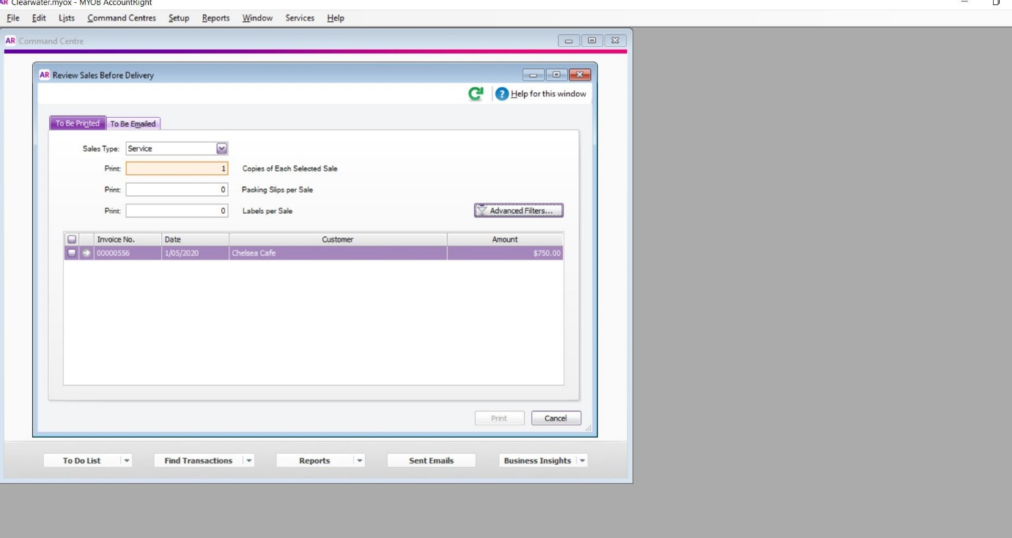

Online Training Skills Test
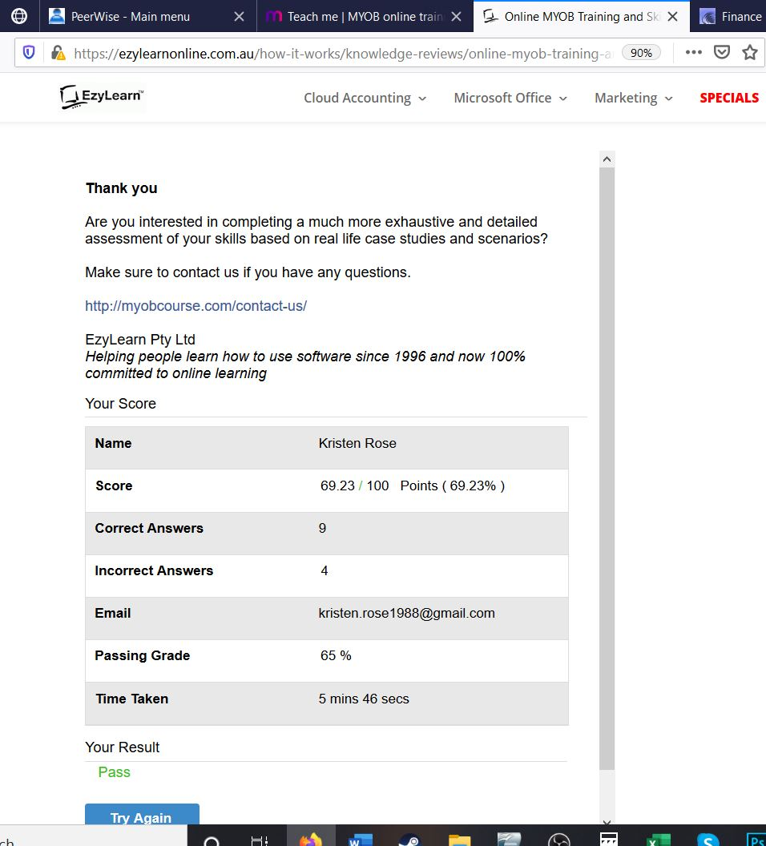

Step 9 – Producing Financial Statements from MYOB
This step seems pretty overwhelming, but I start first with figuring out my 10 hypothetical transactions that seem relevant to my company, Boral LTD. I used their website/products as inspiration for my transactions. Here they are:
- Concrete - $72,792
- Limestone - $640,529
- Fibreglass – $980,052
- Steel - $1, 200,000
- Machine Maintenance – $748,264
- Forklifts – $1,753,526
- Asphalt - $ 860,015
- Paint – $102,652
- Land - $3,568,288
- Timber -$ 720,052
For some reason, MYOB wouldn’t let me export my report to Excel, so I have a screen shot of my report instead as well as a PDF of it.
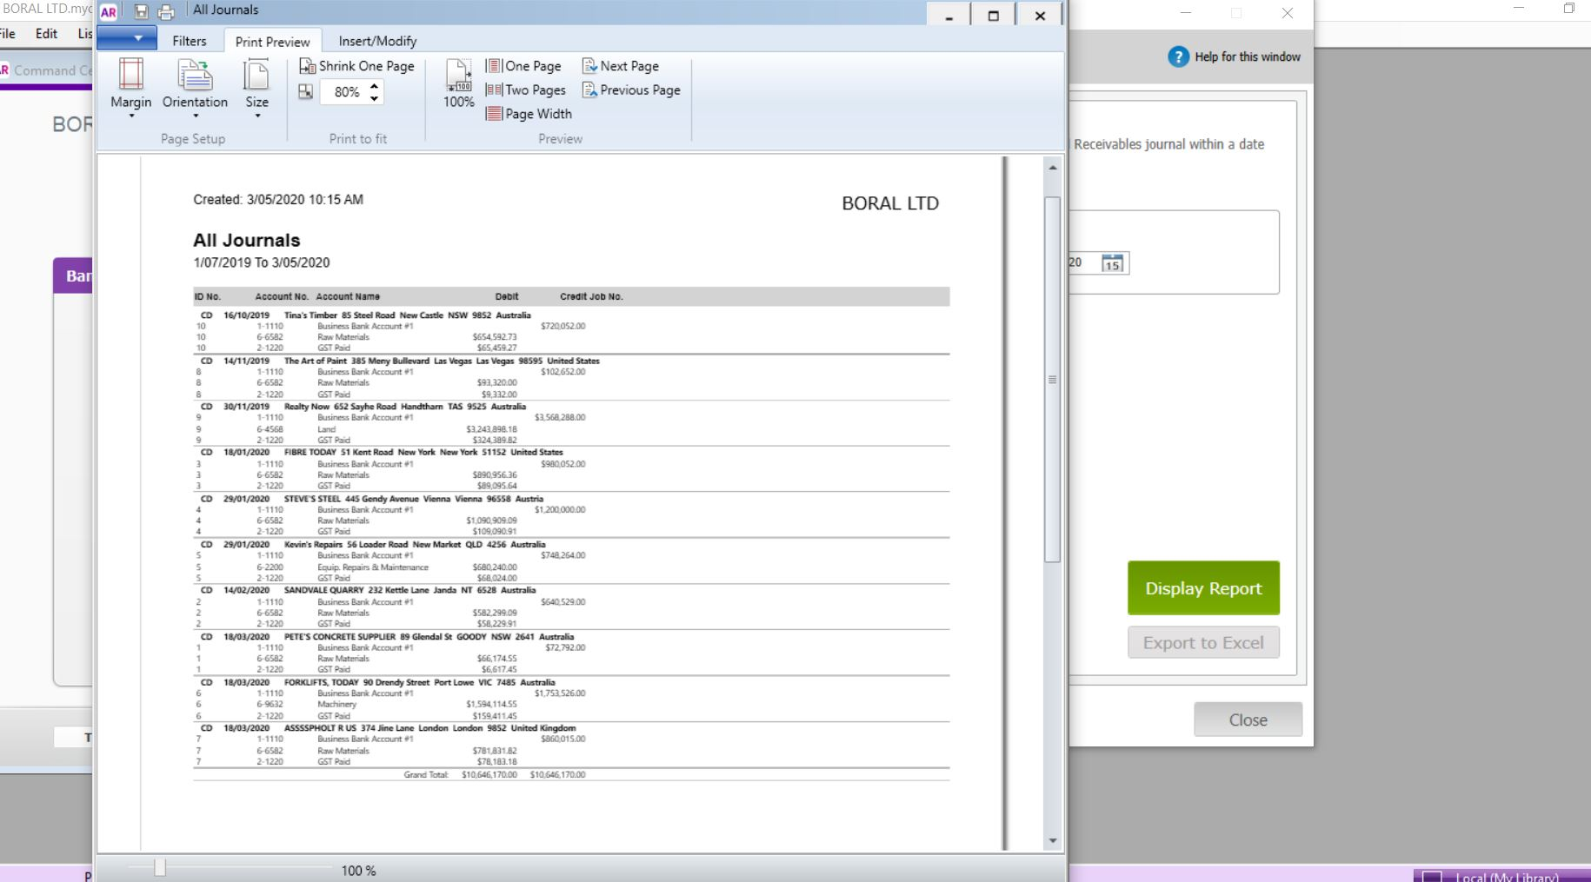

Financial Statements:
Statement of Cash Flow
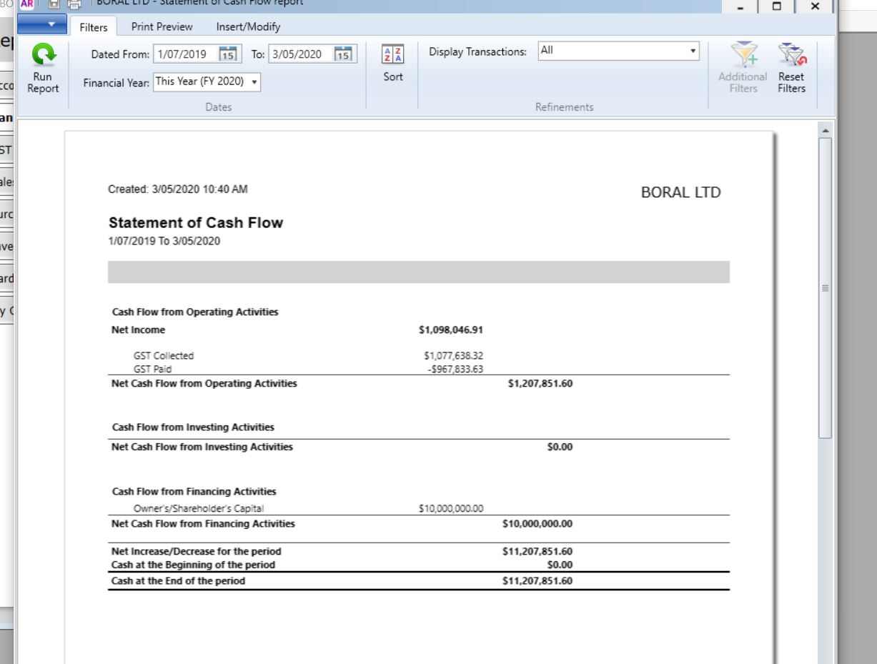
Profit and Loss Statement
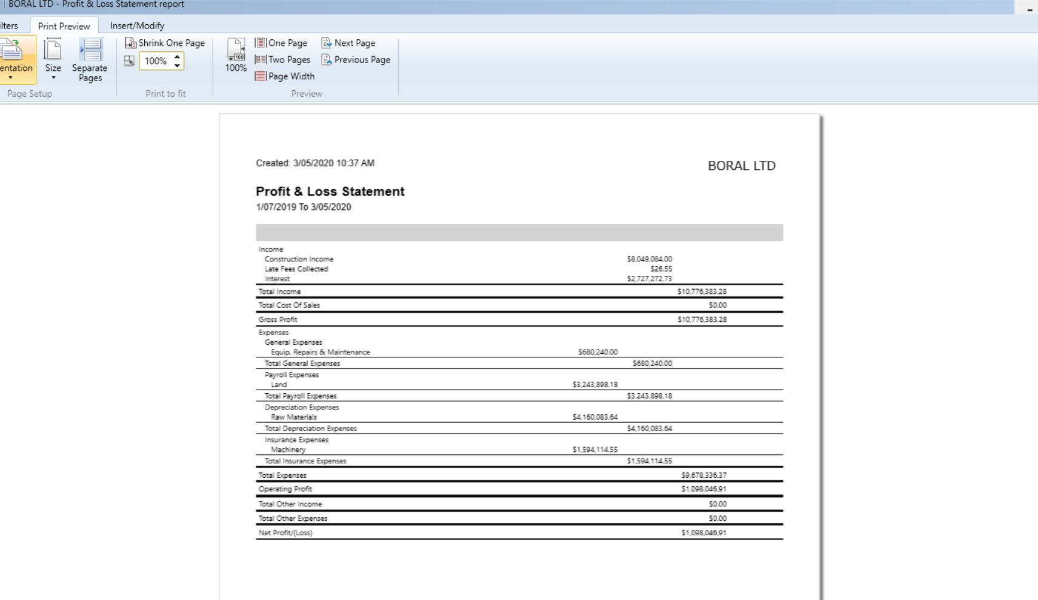

Balance Sheet
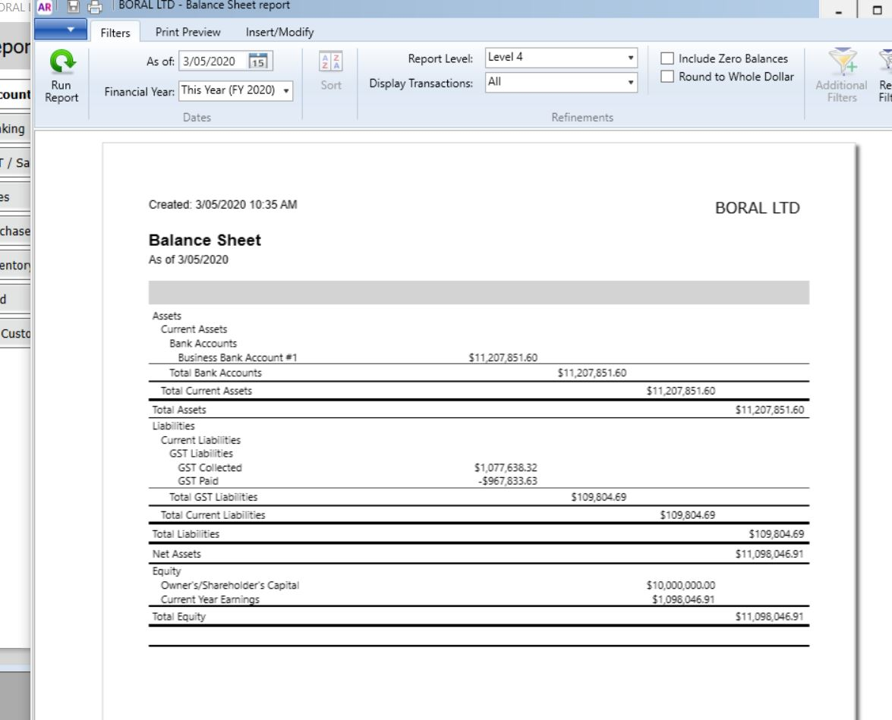
What do the financials mean?
Well, I find myself a little confused as to really what to write in this part, mainly because these financials are all made up. I didn’t input any real numbers from my company. I included the 10 made up transactions as listed above, and in addition to that I also input some money into equity (otherwise my company was running at a huge loss) and I also input a few sales in order to create a profit. If I hadn’t of done those two things, my company would not have had anything in their financial statements outside of the 10 transactions.
As they are, these statements are really quite simple, when compared to Boral’s real financial statements.
Let’s look at each statement one by one and break down what each is saying.
Balance sheet
This is a very simple balance sheet. All 10 of my transactions were purchases made by my company from suppliers. The balance sheet lists the sum of these transactions as assets. My company expects to gain some sort of future economic benefit from these purchases, therefore lists current assets as $11,207,851.60 in the total column.
The liabilities is the GST on these. Because this is something I have purchased, I must pay GST on these assets. It lists the GST paid as $967,833.63.
Therefore my net asset will be my total asset minus the GST paid.
For equity, I input an owner capital of $10,000,000, which is listed under equity. Also listed under equity is the current year’s earnings, which equate to $1,098,046.91. These are sales I made up and input into MYOB in order to give my company some revenue. The total equity is the sum of the two, $11,098,046.91.
This balance sheet doesn’t show expenses or revenue. I’m not really sure why as the purchases I made should be balanced out as expenses, and the sales I made should be balanced as revenue. (Unless I am completely misunderstanding this…)
Profit and Loss (Income) Statement
This statement breaks down all the transaction I created into their relevant accounts. I’m not sure if I made an error here with the name of the accounts (I think maybe) because some of the items I entered it is listing them in the statement as ‘payroll’ expense or ‘depreciation’ expense, which it isn’t (I made up some of my own accounts when I couldn’t find any that matched what I was inputting.)
The income statement shows my investor contribution as income, which is odd as I entered it as owner capital contribution. It has broken this down to include a late fee and interest earned…
My cost of sales is $0.00 which makes sense as I have not entered any inventory in this. The final value of the net profit/loss shows my investment contribution, plus my sales, minus the 10 transactions for the period. Overall my total profit is $1,098,046.91. This concurs with the net profit on the balance sheet.
Statement of Cash Flows
This statement is the simplest of the three, and the one that I think accurately reflects what I entered into MYOB (or at least what my brain understands right now!)
It lists my net income (as previously mentioned) in the first line and shows the GST. Then it lists the owner/shareholder capital contribution of $10 million. The overall cash at the end of the period that it shows is the sum of the two and it then compares this to the previous period. Of course, whilst this is the cash that has entered/exited the business, it is not the current amount of cash in the account. This statement does not include the money that my business spent. Alone, this statement could be quite misleading.
Summary
In summary, I don’t know how well I have done this step, but what is has shown me is how important it is that you accurately enter you data into MYOB so that when these reports are generated they are accurate and make sense. It has also shown me how different these 3 reports are. On their own, they each tell a completely different story. Together, it makes for a better snapshot of a business.
If anything, I feel a lot more suspicious in regards to the accuracy of a financial report as I can now see how easy it is to manipulate and stuff up these reports, even with using an accounting software. (Though, in my defence, I have never use MYOB ever before).

Step 10 - Depreciation
Coming into step 10, I was not overly excited about the task because of how tricky I had found trying to find information on my firm’s inventories, I thought for sure depreciation would be a similar struggle.
I started first by visiting my firms annual reports as recommended and searching them for depreciation. I was happy to find that the depreciation amounts were very easy to locate. In addition, the notes described exactly what method they had used for their depreciation (unlike their lack of description for their inventory method).
I searched the last four year of financials to see if the method Boral has been using was consistent, and luckily it was. So no headaches there.
Boral specifically deduct their depreciation from property, plant and equipment, as stated in their notes section on the income statement. Their depreciation and amortisation figures are listed in a ‘mini’ income statement towards the beginning of the report (not too sure what to call it, it isn’t the proper income statement in their financial report, but it is tilted ‘income statement’ and only shows a few key figures). The same figures of depreciation are also show inn their ‘notes to the statement of cash flows’ section of their reports. They are not shown in any of the official financial statements.
This is the section in all their reports that states, ‘depreciation is calculated to expense the cost of items of property, plant and equipment (excluding freehold land) less their estimated residual values on a straight-line basis over their estimated useful life’.
We learned in the week 8 lecture that there a few ways depreciation can be calculated. The straight line method, as mentioned above, is simply taking the cost of the asset, figuring out how long it will be useful for, and dividing that year number by the price therefore giving a straight line of yearly depreciation. This method makes the most sense to me and really seems to be the most simple method.
Other methods that can be used include the diminishing balance method and the unit-of production method.
The diminishing balance method assumes the asset is more useful in the earlier years, therefore a large amount of depreciation is deducted earlier in the life of the asset and this amount diminishes over time. I think the is method is probably the most realistic method, in the sense that, many assets really are more valuable when you initially buy them, for example a car, and as they years go by, this figure becomes less and less. But, there may be more math and time involved in calculating this one out.
The unit-on-production method allocates a fixed amount per unit, and then based on number of units an amount is calculated. I think in the context of my company Boral, which is a construction company, it has so many different types of assets, this method would get pretty messy to use. If you just had one asset, with one type of unit, this would be an easy method to use and keep track of. However, Boral does use this method for one type of asset – quarry stripping assets. Their notes to property, plant and equipment state ‘Quarry stripping assets are amortised over the expected life of the identified resources using the units of production method.’
Out of interest, I compared the depreciation figures to see if there have been any major increases/decreases over the last four financial years.
- 2016 – Depreciation and Amortisation (246.8) million
- 2017 – Depreciation and Amortisation of (338.4) million
- 2018 – Depreciation and Amortisation of (367.6) million
- 2019 – Depreciation and Amortisation of (377.8) million
Only a major jump between 2016 and 2017, besides this recent years have been fairly consistent. This jump in 2017 could have been due to a large number of new purchases, meaning that they had more assets to depreciate. Or, asserts could have been re-values and gone up in prices, therefore increasing their depreciation figures.
However, when comparing purchase figures between 2016 and 2017, Boral lists ‘purchase of controlled entities and businesses’ in the 2017 report which is not mentioned in the 2016 or 2018 reports and lists this figure as (3636.5) million. This is likely the reason behind the large jump in depreciation. The 2019 report is the only other report which has this listed and the amount is much smaller, only being (10.9) million. This means that the report the release this year, may show a slight of an increase in depreciation, but probably only marginal due to this minor purchase.
The notes to the depreciation go on to say ‘depreciation rates and methods, useful lives and residual values are reviewed each year at each balance sheet date. When changes are made, adjustments are reflected prospectively in current and future financial years only’. This backs up the idea that the jump could have been due to a re-valuation, rather that just a large number of purchases.
Basically this is saying that each year, the value of each asset is re-calculated and then depreciation is adjusted accordingly. If the asset has gone up in value, more depreciation has to be added to it, but if it has gone down, the depreciation figure can be reduced.
Now to look at whether this depreciation is a significant expense for Boral.
- In 2016, depreciation took up 8% of expenses, cost of sales took up 70%, selling and distribution 19%, the remaining 3% to ‘other’.
- In 2017, depreciation took up 6% of the expenses. Whereas cost of sales consumed 70% of the expenses, 18% went to selling and distribution and the remaining percentage to ‘other’
- In 2018 7% went to depreciation, 72% to cost of sales, 17% to selling and distribution and 4% to ‘other’
- In 2019, again 7% to depreciation, 72% to cost of sales, 19% to selling and distribution and 2% to ‘other’
Looking at this breakdown, depreciation percentages appear to be consistent throughout the last four years. As does the amount allocated to cost of sales and selling and distribution. Compared to the latter, depreciation doesn’t seem to be a large portion of Boral’s expenses for the financial year.
Looking at the figures in terms of assets, Boral doesn’t have Goodwill in the non-current asset, the only have property, plant and equipment and intangible assets.
- In 2016, the above mentioned non-current assets are valued at 2752 million. The amount of this allocation to depreciation in this year is 8.9%.
- In 2017, non-current assets are valued at 5964.3 million (remembering in this year Boral documented they made a larger business purchase. For this year depreciation allocation is 5.6%
- In 2018, non-current assets were valued at 6177 million, with a depreciation percentage allocation of 5.9%
- Lastly in 2019, non-current assets were valued at 6252 million, with a deprecation percentage of 6%.
The numbers show that depreciation was slightly higher in 2017. Then in 2018 Boral made a business purchase which increased their asset figure by a significant amount (as well as their depreciation figure). However, it appears that the amount their non-current assets was increased by supersedes the increase in their depreciation. As a result the percentage of their non-current asset that lost to depreciation has lowered.
Journal Entries
2019 Depreciation Journal Entries - Boral LTD
Account | DB | CR
Depreciation and Amortisation Expense | 24.4
Accumulated Depreciation Land and Buildings |  | 24.4
Disposals of Entities or Operations | 14.6
Mineral Reserves, licenses and quarry stripping |  | 14.6
Impairment Disclosed as Significant Items | 3.1
Plant and Equipment |  | 3.1
Balance | 42.1 | 42.1

For my journal entries, accounts and figures have been taken directly out of the Boral Financial Report for 2019.
I’m not really sure how much effect these entries have on my financial statements. These entries are taken from the notes section, but I suppose it is out of interest to note just where the depreciation is coming from. For example, is most of the depreciation in Land, or is it in quarries, or plant and equipment? If this was included in the financial statements then it could give more of an idea as to what non-current asset is the most expensive to keep in terms of depreciation costs. It also shows exactly where Boral keep their assets and provides more insight into what they have more of.
It’s certainly easy to manipulate these entries by lumping them all into one category. A firm may not separate its assets into their entities but rather keep them all just as one lump account, therefore making it unclear exactly where these assets are held and what particularly produces the most depreciation. Or it could completely omit all individual figures from the financial statements so you have no idea what the assets are and how much of them as attributed towards depreciation.

